**Docker Swarm**

Docker Swarm is a container orchestration tool that allows you to manage a cluster of Docker nodes as a single logical system. It provides several benefits, such as scalability, high availability, load balancing, and simplified deployment. Here are some use cases and examples of how Docker Swarm can be utilized:

### **1. High Availability Web Application**

**Steps:**

**Initialize Swarm:**  
docker swarm init --advertise-addr <MANAGER-IP>

**Add Worker Nodes:** On each worker node:  
  
docker swarm join --token <WORKER-TOKEN> <MANAGER-IP>:2377

**Deploy a Web Application:**  
docker service create --name webapp --replicas 3 -p 80:80 nginx

**Check Service Status:**  
docker service ls

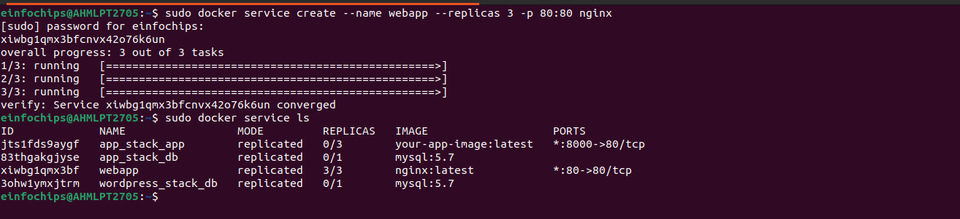

### **2. Continuous Integration/Continuous Deployment (CI/CD) Pipeline**

**Steps:**

**Initialize Swarm and Deploy Jenkins:**

1. **Configure Jenkins to Deploy to Swarm:**
2. **Automate Deployment:**

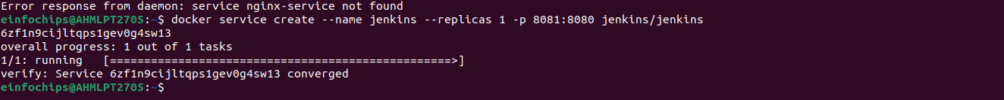

### **3. Load Balancing and Scaling Services**

**Steps:**

**Initialize Swarm:**

**Deploy a Service with Load Balancing:**

**Scale the Service:**

